**Ideation Phase**

**Empathize & Discover**

|  |  |
| --- | --- |
| Date | 29 August 2025 |
| Team ID | LTVIP2025TMID61033 |
| Project Name | Order On The Go |
| Maximum Marks | 4 Marks |

**Empathy Map Canvas:**

Understand the needs, thinking, work, feelings, pains and gains of customers seeking for comforting food through a platform like Order on the Go.

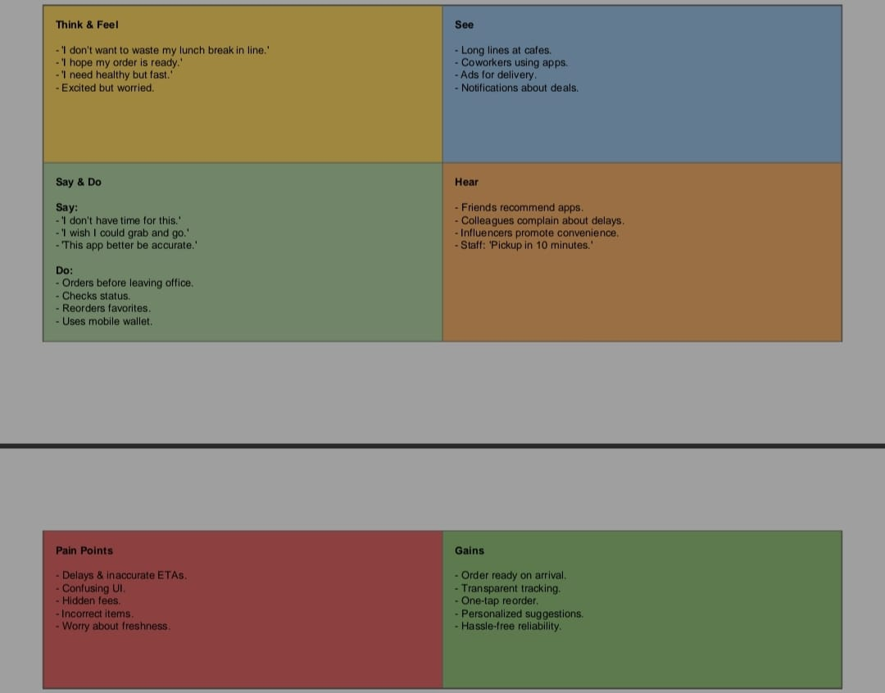

Reference: <https://www.mural.co/templates/empathy-map-canvas>